DYMO Connect Installation on macOS

# Extra Authentication Steps in DYMO Connect Installer

The DYMO Web Service installation is selected by default in the DYMO Connect installer. To avoid installing the Web Service and these extra authentication steps, select **Customize** during installation. Otherwise, two additional authentication steps are needed.

1. At the end of the installation, click **Close**.

The Terminal app displays with the Password prompt. This could take 30 to 60 seconds after closing the installer.

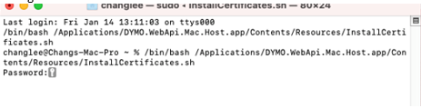

1. Enter your log in password at the prompt and press **Enter**.

Another password dialog displays asking for your login password again.

1. Enter your password and click **Update Settings**.

# Troubleshooting Web Service

The DYMO Web Service may not install correctly. To verify, you can diagnose the installation.

To diagnose the Web Service installation

1. Look for the DYMO icon  on the menu bar.



If the icon is not displayed, skip to **Add Web Service on Start Up**.

1. Click the icon and select **Diagnose** from the menu.

The following message appears when the Web Service is installed successfully.

1. Click **Ok**.
2. If the installation failed, click **Stop service** from the  menu and then click **Start service**.

# Add Web Service on Start Up

When you restart your system or log in to your account and the Web Service has not started, the  icon will not appear in the menu bar. You will need to add the DYMO Web Service app as a login item manually.

1. Open **System Preferences**.
2. Click **Users & Groups**.

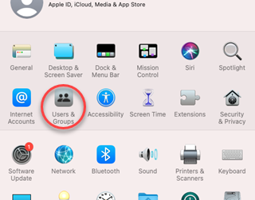

1. Click + button at the bottom of Login Items tab on Users & Groups screen

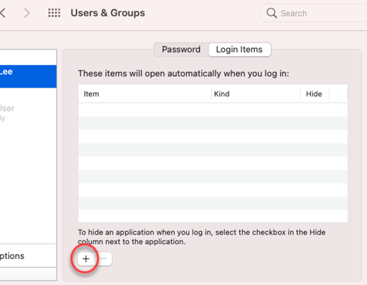

1. From the Applications folder, select **DYMO.WebApi.Mac.Host.app** to add to your Login Items and click **Add**.

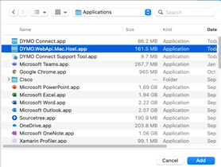

When DYMO.WebApi.Mac.Host.app is listed in Login Items, the DYMO Web Service will start automatically when you restart or log in.

